Assignment 3 :

1.Create a comparison table listing the main differences between DDR3, DDR4, and DDR5 RAM, including speed, voltage, and typical use cases.(DOUBLE DATA RATE)

Feature | DDR3 | DDR4 | DDR5
Release Year | 2007 | 2014 | 2020
Speed (JEDEC Standard) | 800–2133 MT/s | 1600–3200 MT/s | 4800–8800 MT/s
Voltage | 1.5 V | 1.2 V | 1.1 V
Bandwidth | Up to ~17 GB/s | Up to ~25.6 GB/s | Starts at ~38.4 GB/s and higher
Maximum Module Capacity | Up to 16 GB | Up to 64 GB | 128 GB and beyond
Power Efficiency | Lowest | Better than DDR3 | Best among the three
Latency | Lower absolute latency | Moderate | Higher latency numbers but much faster overall due to increased speed
Error Correction | No on-die ECC | No on-die ECC | On-die ECC (improves reliability internally)
Compatibility | DDR3-only motherboards | DDR4-only motherboards | DDR5-only motherboards
Physical Notch | Different position | Different from DDR3 | Different from DDR4
Typical Use Cases | Older desktops and laptops | Mainstream PCs, gaming, office work | High-end gaming, content creation, AI workloads, future PCs

3.Open your laptop or desktop (with power disconnected), locate the RAM slots, and take a clear photo of the installed RAM module. Reinstall the RAM module and verify that your system boots up successfully.<br><br><em><strong>Hint:</strong> Refer to your device manual or a trusted YouTube guide if unsure about RAM removal and installation steps.</em>

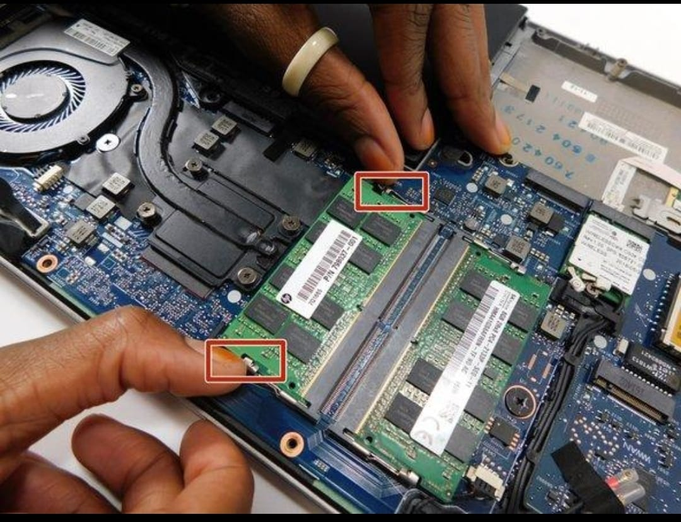

3.List three key differences between HDD, SSD, and NVMe storage types, and for each, name one app or use case (from apps you use daily) that would benefit most from that storage type.

Feature | HDD |  |  | SSD (SATA) | NVMe SSD
Speed | Slow (80–160 MB/s) |  |  | Fast (500–550 MB/s) | Very Fast (2,000–7,000+  MB/s)
Technology | Spinning magnetic disks |  |  | Flash memory (no moving parts) | Flash memory using PCIe  Interface
Best Use Case | Large, low-cost storage |  |  | Everyday Windows use and applications | High-performance tasks like  gaming, video editing, and large file transfers

Storage Type | Daily App or Use Case | Why It Benefits
HDD | Movies, Photos, Music collection | Large storage capacity at a low cost.
SSD  (SATA) | Google Chrome / Microsoft Office | Faster startup and quicker loading of applications.
NVMe SSD | Adobe Premiere Pro (or modern games like BGMI emulators/AAA PC games) | Extremely fast loading, file transfers, and project processing.

4. Remove the storage drive (HDD or SSD) from your system, take a photo of the connector type (SATA, M.2, or NVMe), and reinstall the drive. Confirm that your device recognizes the storage after reassembly.<br><br><em><strong>Constraint:</strong> Only perform this task if you have access to a device you are allowed to open. If not, find and share a YouTube video link showing the process for your laptop/PC model.</em>

